COIT20265: Networks and Information Security Project
TECHNICAL ARTEFACT

NF-CSE-CIC-IDS2018-v2 Cross-Dataset Preparation & Compatibility Engineering

Explainable and False-Positive-Aware Hybrid Unsupervised Network Anomaly Detection for Australian SME Financial Services

Student | Syed Rubaiyat Karim
Student ID | 12302352
Project Group | PG3
Term | HT2 2026
Prepared | October 2026
Individual contribution: NF-CSE-CIC-IDS2018-v2 preprocessing, feature-compatibility engineering, cross-dataset preparation, verification and reproducibility evidence.

Executive Summary
This artefact documents the engineering required to convert NF-CSE-CIC-IDS2018-v2 into a defensible external-domain test input for six anomaly-detection models developed on UNSW-NB15. The task was not ordinary dataset cleaning. The source file contains 18,893,708 flows and is approximately 3.0 GB in the supplied Colab environment; the trained models expect a fixed 41-column representation produced by the UNSW preprocessing contract. The implementation therefore had to control memory use, preserve labels only for evaluation, construct portable network features from a different schema, reuse the saved source-domain preprocessor without refitting, and verify exact feature order before inference.
The executed notebook scanned all 18,893,708 source rows in 200,000-row chunks, removed five duplicate records detected within chunks, built sampling pools, and retained a fixed-seed evaluation sample of 700,000 flows: 400,000 normal and 300,000 attack. The attack sample was stratified across 14 attack labels. From the selected records, the notebook engineered 21 portable features and then loaded the saved UNSW preprocessor to produce 41 model-ready columns. Final assertions confirmed a 700,000 × 41 matrix, 700,000 labels, zero NaN values and zero infinite values.
Table of Contents
Executive Summary 2
1. Project Role, Problem and Scope 3
1.1 Role of NF-CSE-CIC-IDS2018-v2 in the project 3
1.2 Artefact-specific problem statement 3
1.3 Scope and contribution boundary 3
1.4 Artefact objectives 3
2. Dataset Provenance and Research Basis 4
2.1 Official source 4
2.2 Why this dataset was selected 4
2.3 Official prevalence versus project evaluation sample 5
3. Requirements and Acceptance Criteria 5
4. Implementation Environment, Code Provenance and Evidence 6
4.1 Execution environment 6
4.2 Code origin and source provenance 6
4.3 Reproducibility packaging check 6
5. End-to-End Preprocessing Architecture 7
6. Data Ingestion, Validation and Sampling 8
6.1 Memory-safe chunk processing 8
6.2 Label and invalid-value handling 8
6.3 Duplicate control - what the code actually guarantees 8
6.4 Two-stage deterministic sampling design 8
7. Feature Engineering and Cross-Dataset Compatibility 8
7.1 Why a portable layer is necessary 8
7.2 Direct and arithmetic feature mappings 9
7.3 Protocol, service and state mapping 9
7.4 Rolling connection-context features 10
7.5 Reuse of the UNSW preprocessor and 41-column contract 10
8. Output Artefacts and Verification 10
8.1 Delivered files 10
9. Dataset Composition and Attack Coverage 11
10. Critical Evaluation of Portability and Domain Shift 12
10.1 Structural, transformation and semantic compatibility 12
10.2 Downstream evidence of domain shift 12
10.3 Design decisions and justification 12
11. Reproducibility and Quality Assurance 13
11.1 Controls already demonstrated 13
11.2 Reproducibility hardening required before final archive 13
11.3 Recommended additional verification 13
12. Ethical and Professional Considerations 13
13. Limitations and Recommendations 13
14. Conclusion 14
Appendix A - Exact 41-Column Model Contract 14
Appendix B - Implementation Evidence Index 15
References 15

1. Project Role, Problem and Scope

1.1 Role of NF-CSE-CIC-IDS2018-v2 in the project
UNSW-NB15 is the source domain used to develop the normal-only / one-class anomaly detectors. NF-CSE-CIC-IDS2018-v2 is deliberately used as a different target domain. The six saved models are not retrained on NF-CSE during the frozen-transfer experiment. Instead, NF-CSE records are translated into the portable feature contract and passed through the saved UNSW transformation pipeline. This makes the dataset useful for answering a deployment question that an ordinary within-dataset split cannot answer: what happens when a detector encounters network traffic produced by a different capture and aggregation environment?

1.2 Artefact-specific problem statement
A trained model cannot consume a second dataset merely because both datasets describe network flows. Field names, units, protocol encodings, service representations, temporal context and aggregation rules differ. A correct preprocessing artefact therefore has to do more than make an array with 41 columns. It must document how each required input is obtained, which mappings are direct, which are derived, where the semantics are approximate, and how the original source-domain preprocessor is reused without allowing target data to change it.

1.3 Scope and contribution boundary
Included in this artefact | Handled in another artefact
Official NF-CSE provenance and source validation | UNSW-NB15 source-domain preparation
Memory-safe full-file scan and reproducible 700k sample | Training/tuning the six anomaly models
NF-CSE → 21 portable feature engineering | GNS3/VMware topology and Zeek capture
Reuse of saved UNSW preprocessor to obtain 41 inputs | Final multi-model threshold recalibration and sensitivity analysis
Output verification, evidence files and limitations | Streamlit dashboard and explainability implementation

1.4 Artefact objectives
ID | Objective | Evidence of completion
O1 | Process the complete 18.9M-row source without a full in-memory load | Chunked scan completed across 18,893,708 rows.
O2 | Create a deterministic external-domain test sample | Seed-controlled 400k normal + 300k attack sample.
O3 | Construct the same 21 portable feature names used by the UNSW pipeline | Portable matrix verified at 700,000 × 21.
O4 | Apply the source-domain preprocessor without target-domain refitting | preprocessor.joblib loaded and transform() applied in batches.
O5 | Enforce the exact 41-column model contract | Output names verified/reordered; final matrix 700,000 × 41.
O6 | Export auditable evidence for later model evaluation | NPZ, metadata, feature-order JSON, summary, distribution and preview outputs.
O7 | Document semantic limitations rather than treating shape compatibility as equivalence | Field-level fidelity and rolling-context limitations explicitly evaluated.

2. Dataset Provenance and Research Basis

2.1 Official source
NF-CSE-CIC-IDS2018-v2 is a University of Queensland NetFlow V2 dataset derived from the original CSE-CIC-IDS2018 packet captures. The UQ dataset catalogue describes the V2 family as using 43 extended NetFlow features and reports 18,893,708 flows for NF-CSE-CIC-IDS2018-v2: 16,635,567 benign (88.05%) and 2,258,141 attack (11.95%). The dataset is published for academic research and is associated with DOI 10.48610/e9636b7 (University of Queensland 2023; Sarhan, Layeghy & Portmann 2022).
Property | Official dataset | Project evidence
Dataset | NF-CSE-CIC-IDS2018-v2 | Same dataset name and raw CSV path recorded in notebook.
Origin | CSE-CIC-IDS2018 packet captures converted to NetFlow V2 | Used as an external target domain, not a continuation of UNSW.
Official flow count | 18,893,708 | Notebook output: 18,893,708 rows inspected.
Official benign count | 16,635,567 (88.05%) | The project retained 400,000 normal records.
Official attack count | 2,258,141 (11.95%) | The project retained 300,000 attack records.
V2 representation | 43 extended NetFlow features | Project maps required raw fields into a 21-feature portable contract.

2.2 Why this dataset was selected
The dataset is useful precisely because it differs from UNSW-NB15 while remaining network-flow oriented. Cross-dataset NIDS research repeatedly shows that strong within-dataset scores do not guarantee transfer when traffic sources, exporters, feature definitions and class distributions change (Sommer & Paxson 2010; Ring et al. 2019). Sarhan et al. developed the NF family to make cross-dataset comparison more practical through NetFlow-oriented representations, but a common NetFlow philosophy does not make every field semantically identical. The project therefore treats NF-CSE as an unseen target environment and records the mapping assumptions explicitly.

2.3 Official prevalence versus project evaluation sample
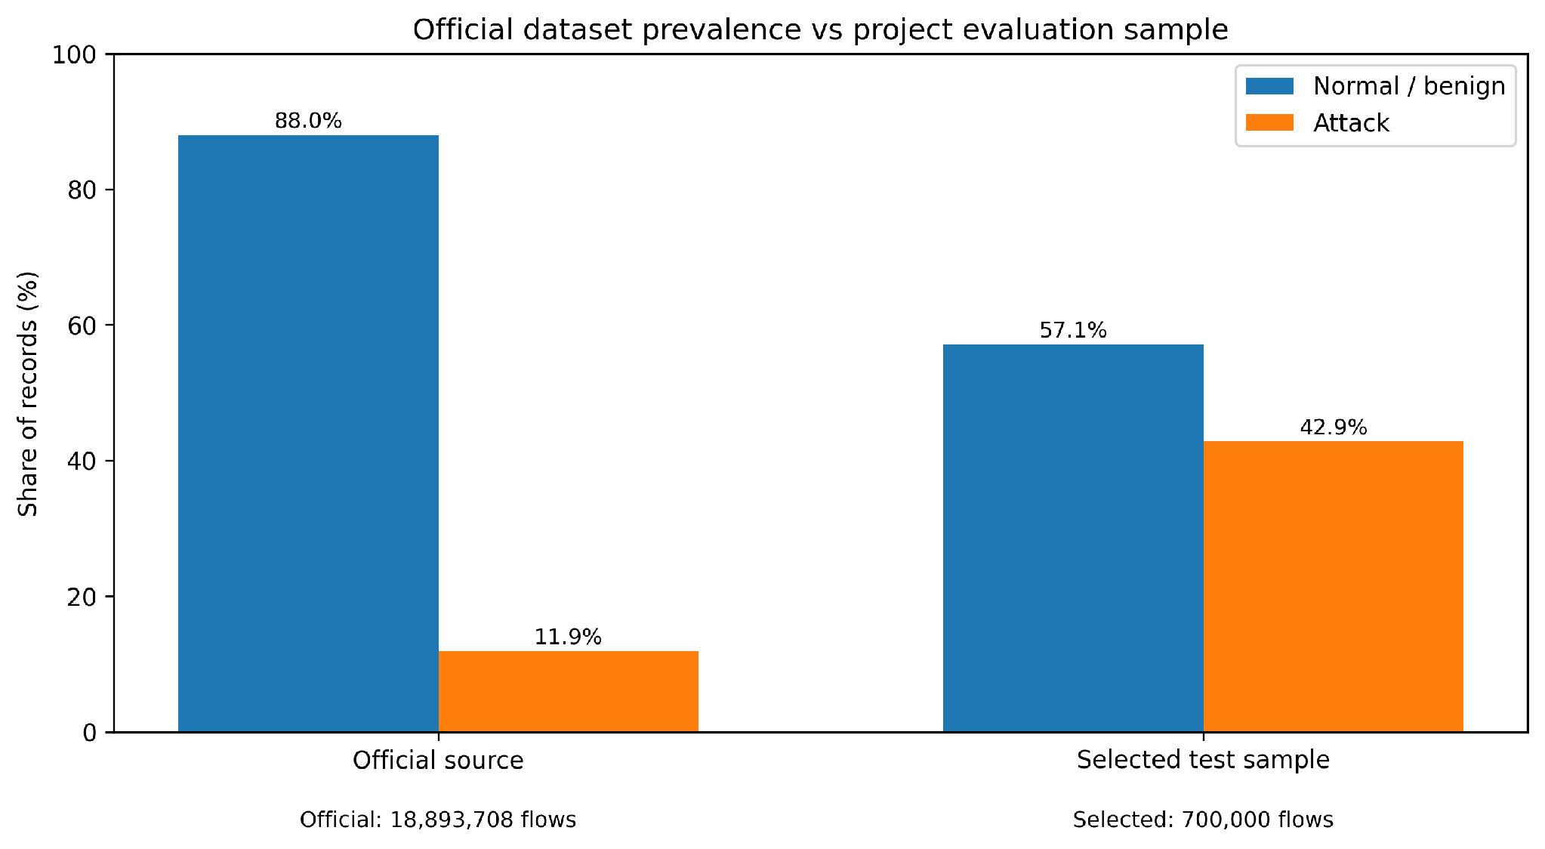
Figure 1. The 700,000-record project sample is deliberately evaluation-oriented and must not be interpreted as real-world prevalence.
The project sample contains 57.14% normal and 42.86% attack traffic, whereas the official source is 88.05% benign. This rebalancing is useful for obtaining enough labelled attack examples for comparative evaluation, but it changes the meaning of precision because precision depends on class prevalence. False-positive rate remains especially important because its denominator contains only normal records.

3. Requirements and Acceptance Criteria
Requirements were defined as engineering controls so the artefact could be verified from saved evidence rather than from a narrative claim.
ID | Requirement | Acceptance evidence
DP1 | Scan the source without exhausting Colab memory. | Chunk iterator completes across the full 3.0 GB file.
DP2 | Retain only records with numeric binary labels. | Saved y contains only 0 and 1.
DP3 | Prevent direct identifiers and labels from entering the 41 model inputs. | Identifiers are used only where needed for mapping/metadata; final X contains model features only.
DP4 | Create a reproducible working sample. | Seed 42; exactly 400k normal + 300k attack.
DP5 | Preserve attack-category diversity in the selected attack sample. | Stratified selection from the attack pool; 14 labels present.
DP6 | Use the same 21 portable feature names expected by the source preprocessor. | feature_names_in_ checked against FEATURES_21.
DP7 | Do not refit the UNSW preprocessor on target traffic. | Saved preprocessor loaded; transform() only.
DP8 | Produce exactly 41 finite model-ready columns in the expected order. | 41 columns, no NaN/inf, name/order validation.
DP9 | Export provenance and human-readable inspection evidence. | Metadata, JSON summary, feature order, preview and attack distribution saved.
DP10 | Document mappings that are only approximations. | Semantic-fidelity table and limitations included.

4. Implementation Environment, Code Provenance and Evidence

4.1 Execution environment
Element | Verified implementation detail
Platform | Google Colab notebook with Google Drive mounted at /content/drive.
Notebook | https://colab.research.google.com/drive/1yTAbr_MMHYhzCL6tkPG3QI0lJUobvi44
Project root | /content/drive/MyDrive/intentmap-nids/intentmap-nids
Raw input | data/raw/NF-CSE-CIC-IDS2018-v2.csv (reported by notebook as 3.0 GB)
Source preprocessor | models/preprocessor.joblib
Source feature order | config/feature_order.json
Target output directory | data/processed/nf_cse
Figure output directory | results/figures
Main libraries | pandas, NumPy, scikit-learn, joblib, pathlib, collections, matplotlib

4.2 Code origin and source provenance
The supplied notebook is the implementation evidence for this artefact. Its project-specific logic includes chunked sampling, NF-CSE-to-portable feature construction, protocol/service/state mapping, rolling context counts, reuse of the saved UNSW preprocessor, output reordering and final assertions. The notebook does not identify an external repository from which this project-specific code was copied. It relies on standard open-source Python libraries whose APIs are cited where relevant.
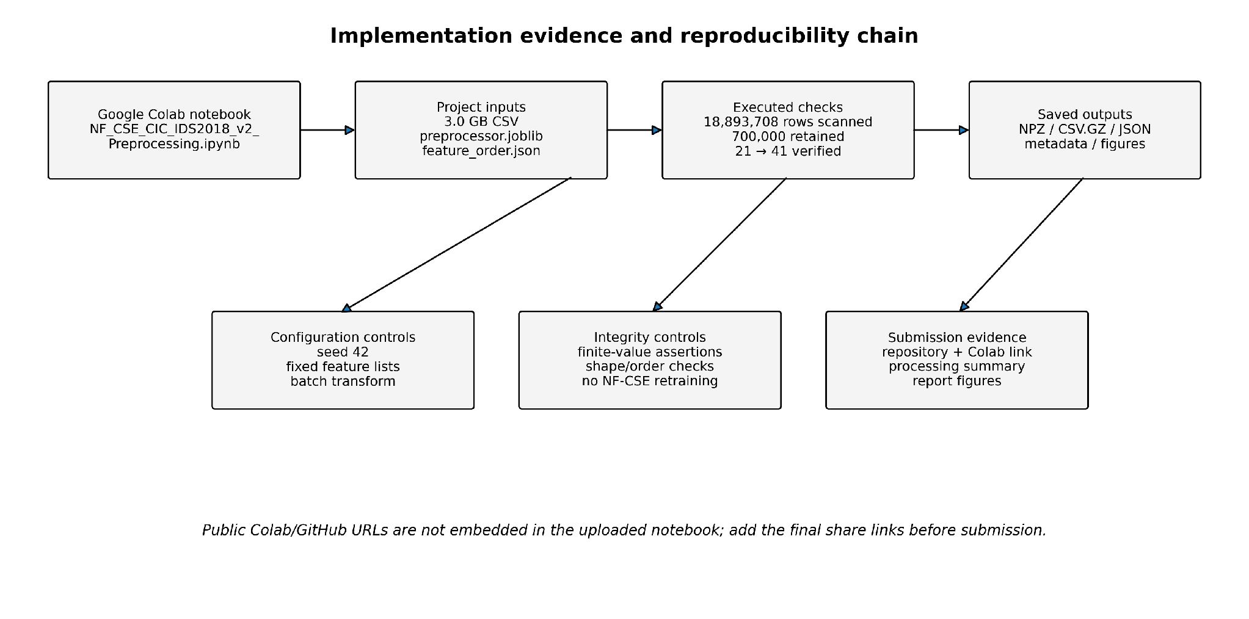
Figure 2. Code, input, execution and output evidence chain. Public share URLs must be added from the team-owned accounts.

4.3 Reproducibility packaging check
Notebook verification (uploaded NF_CSE_CIC_IDS2018_v2_Preprocessing notebook): the sampling cell references CHUNK_SIZE, LABEL_COL, ATTACK_COL, KEEP_COLUMNS, NORMAL_POOL_PROB, ATTACK_POOL_PROB, MAX_NORMAL and MAX_ATTACK without definitions in preceding visible cells. Its saved output establishes that a runtime executed the sampling stage, but the uploaded notebook is not demonstrably restart-and-run reproducible. A definitive reproducibility claim requires adding one explicit configuration cell, restarting the runtime and executing all cells sequentially; this verification has not been performed in this document.
The executed notebook contains strong run evidence, but the uploaded copy references several configuration variables in the sampling cell before a visible definition appears: CHUNK_SIZE, LABEL_COL, ATTACK_COL, KEEP_COLUMNS, NORMAL_POOL_PROB, ATTACK_POOL_PROB, MAX_NORMAL and MAX_ATTACK. The recorded outputs prove that an executed runtime contained these values, but a clean runtime copy should not depend on hidden or previous state. For final archival quality, those constants should be consolidated into one visible configuration cell and the notebook rerun from top to bottom before the Colab link is shared.

5. End-to-End Preprocessing Architecture
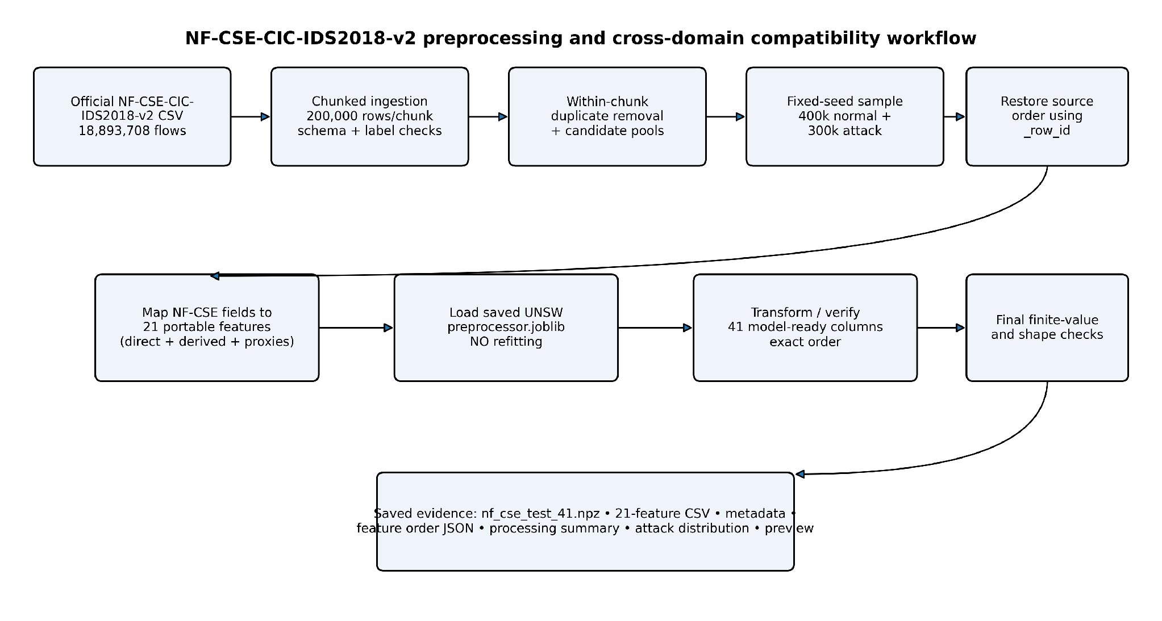
Figure 3. Actual preprocessing workflow reconstructed from the supplied notebook and its executed outputs.
The workflow deliberately separates source scanning, sample selection, feature construction and model-contract transformation. This separation matters because target labels and target statistics must not change the model or the source-domain transformation contract during the frozen-transfer experiment.
Stage | Input | Operation | Verified output
Source validation | NF-CSE CSV + saved UNSW artefacts | Existence and path checks | 3.0 GB CSV; preprocessor and feature-order files found.
Streaming scan | 200k-row chunks | Column cleanup, inf→NaN, within-chunk duplicate detection, label validation | 18,893,708 rows inspected; 5 duplicates removed within chunks.
Candidate pools | Valid normal/attack rows | Seeded probabilistic pool sampling | 498,827 normal candidates; 384,022 attack candidates.
Exact selection | Candidate pools | 400k normal sample + stratified 300k attack sample | 700,000 retained records.
Order restoration | Selected records | Sort by original _row_id | Source-order sequence retained among selected rows.
Portable feature layer | Selected raw fields | Direct, derived, mapped and rolling features | 700,000 × 21; no missing values.
Source transformation | 21 portable features | Load saved preprocessor; batch transform | 700,000 × 41.
Verification/export | 41-feature matrix + labels | Finite-value assertions; save evidence files | All final checks passed.

6. Data Ingestion, Validation and Sampling

6.1 Memory-safe chunk processing
The source was not loaded as one DataFrame. The notebook used pandas.read_csv(..., chunksize=CHUNK_SIZE) and recorded progress every ten chunks. The output advanced in two-million-row increments, which confirms a 200,000-row chunk size for the executed run. Treating chunk size as an execution parameter allows the same logic to operate under tighter memory constraints without changing the scientific selection rules.

6.2 Label and invalid-value handling
Column names are stripped before rules are applied. Positive and negative infinity are replaced by missing values at the source-scanning stage. Labels are converted with numeric coercion; rows whose labels cannot be converted are rejected rather than guessed. Attack names are retained for evaluation metadata, while the model matrix is built later from a controlled set of network fields.

6.3 Duplicate control - what the code actually guarantees
Code-level qualification: chunk[duplicate_check_columns].duplicated() removes duplicates only within each currently loaded chunk; the excluded _row_id prevents a unique row identifier from masking equality. The recorded removal of five rows is therefore a within-chunk finding and cannot establish that the 18,893,708-row source has only five duplicated flows. A global deduplication result would require a separate cross-chunk fingerprint or key-based audit.
The notebook checks duplicates inside each chunk after adding an original row identifier, but it excludes _row_id from the duplicate comparison. Five duplicate records were removed during the executed full-file scan. This is a useful quality control, but it is not proof that no duplicate row exists across two different chunks because the duplicate state is not carried between chunks. The report therefore describes this accurately as within-chunk deduplication rather than global deduplication.

6.4 Two-stage deterministic sampling design
Sampling-parameter evidence: the code creates seeded per-chunk candidate pools and then chooses exactly 400,000 normal flows using DataFrame.sample(random_state=42) and 300,000 attacks using train_test_split(train_size=MAX_ATTACK, random_state=42, stratify=attack_pool[ATTACK_COL]). The exact candidate-pool inclusion probabilities cannot be independently verified from the uploaded notebook because their variable assignments are not visible. Source-order sorting by _row_id is performed only after selection; omitted flows remain absent from subsequent context calculations.
The scan first builds manageable normal and attack candidate pools using a seeded random generator that changes deterministically by chunk number. An exact normal sample of 400,000 is then drawn with random_state=42. The 300,000 attack sample is selected with train_test_split(..., stratify=attack category), preserving attack-category representation within the candidate attack pool. The selected rows are concatenated and sorted by their original _row_id before feature construction.
Executed quantity | Result
Raw rows inspected | 18,893,708
Duplicates removed within chunks | 5
Normal candidate pool | 498,827
Attack candidate pool | 384,022
Selected normal records | 400,000
Selected attack records | 300,000
Final sample | 700,000

7. Feature Engineering and Cross-Dataset Compatibility

7.1 Why a portable layer is necessary
The UNSW-trained models do not consume NF-CSE native fields directly. They consume a 41-column model representation generated from a 21-feature portable schema. The compatibility layer therefore maps NF-CSE source fields to those 21 names first, then passes the result through the saved UNSW preprocessor. This preserves the source-domain model contract while making every approximation visible.
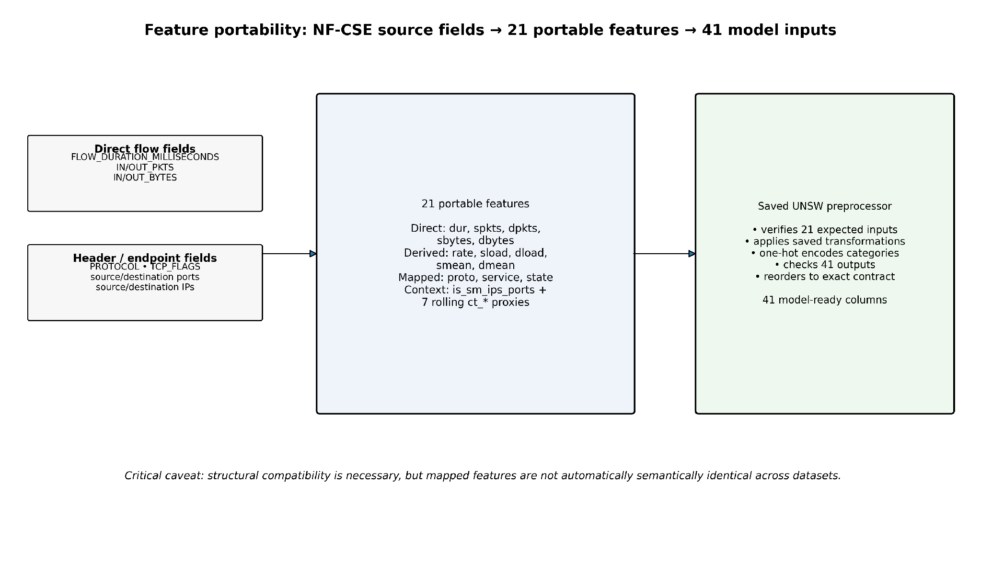
Figure 4. Three-layer compatibility design: source fields, 21 portable features and the 41-column model contract.

7.2 Direct and arithmetic feature mappings
Portable feature | NF-CSE source / formula | Mapping type | Semantic confidence
dur | FLOW_DURATION_MILLISECONDS / 1000 | Derived unit conversion | High
spkts | IN_PKTS | Direct rename | High
dpkts | OUT_PKTS | Direct rename | High
sbytes | IN_BYTES | Direct rename | High
dbytes | OUT_BYTES | Direct rename | High
rate | (spkts + dpkts) / dur; 0 when dur=0 | Derived formula | Medium-High
sload | (sbytes × 8) / dur; 0 when dur=0 | Derived formula | Medium-High
dload | (dbytes × 8) / dur; 0 when dur=0 | Derived formula | Medium-High
smean | sbytes / spkts; 0 when spkts=0 | Derived formula | High
dmean | dbytes / dpkts; 0 when dpkts=0 | Derived formula | High

7.3 Protocol, service and state mapping
Protocol is mapped from IP protocol number: 6→tcp, 17→udp, all other values→other. Service is inferred from either source or destination port using explicit rules for DNS, FTP/FTP-data, HTTP, POP3, RADIUS, SMTP, SNMP and SSH; unmatched traffic is “-”. The connection state is reconstructed from protocol and TCP flags. ICMP protocol 1 maps to ECO, UDP to INT, TCP RST/FIN/SYN/ACK combinations map to RST, FIN, REQ or CON, and unmatched rows use no.
Mapping | Rule used in notebook | Technical limitation
proto | 6=tcp; 17=udp; otherwise=other | Collapses all non-TCP/UDP protocols into one category except ICMP state handling.
service | Port-based service inference from source or destination port | Port does not guarantee application identity; non-standard ports can be mislabelled.
state | PROTOCOL + TCP_FLAGS heuristic | Not guaranteed to reproduce the exact state semantics used by UNSW/Argus.
is_sm_ips_ports | same source/destination IP AND same source/destination port | Direct logical proxy; depends on retained endpoint identifiers during feature construction.

7.4 Rolling connection-context features
Semantic-fidelity qualification: the last-100-record deque runs over the selected, row-ID-sorted sample rather than the original uninterrupted 18.9-million-flow sequence. Thus ct_* values count neighbouring retained records, not necessarily the preceding 100 source-domain flows or the exact UNSW/Argus connection windows. This difference may materially affect cross-domain anomaly scores; structural compatibility alone should not be interpreted as verified equivalence.
Seven ct_* features are reconstructed with a deque containing the previous 100 selected records. Per-window dictionaries count service/source, service/destination, destination, source, source/destination-port, destination/source-port and source-destination pair occurrences. This produces the expected feature names, but their semantics are necessarily approximate because the original UNSW connection-count definitions and the NF-CSE event sequence are not identical.
Portable feature | Counter key | Implemented context window
ct_srv_src | (service, source IP) frequency | Last 100 selected records
ct_srv_dst | (service, destination IP) frequency | Last 100 selected records
ct_dst_ltm | destination IP frequency | Last 100 selected records
ct_src_ltm | source IP frequency | Last 100 selected records
ct_src_dport_ltm | (source IP, destination port) frequency | Last 100 selected records
ct_dst_sport_ltm | (destination IP, source port) frequency | Last 100 selected records
ct_dst_src_ltm | (source IP, destination IP) pair frequency | Last 100 selected records

7.5 Reuse of the UNSW preprocessor and 41-column contract
Verification boundary: the code loads the persisted UNSW preprocessor using joblib.load and conditionally checks feature_names_in_ and get_feature_names_out where those interfaces are available. It enforces 41 output columns and finite model inputs, but these checks establish schema/numeric validity—not equivalence of service, state or temporal-feature semantics. No refitting of the source preprocessor is visible in this processing stage.
The notebook loads models/preprocessor.joblib rather than fitting a target-domain scaler or encoder. If the saved object exposes feature_names_in_, the 21 expected names are checked against the portable schema. The transformed output is generated in 100,000-row batches. Where get_feature_names_out() is available, prefixes are removed, the 41 output names are compared as a set, and a reordering index is built to force the exact project order. A shape check rejects any transform that does not produce 41 columns, and a finite-value assertion rejects NaN or infinite model inputs.

8. Output Artefacts and Verification

8.1 Delivered files
Output | Purpose | Notebook verification
nf_cse_test_41.npz | Final cross-dataset matrix X and binary labels y | X=(700,000,41); y=(700,000,)
nf_cse_21_features.csv.gz | Portable intermediate representation | 21 columns; no missing values before saved transformation.
nf_cse_test_metadata.csv.gz | row_id, label, attack, endpoints, ports and mapped protocol/service/state | Supports traceability and investigation; not model input.
feature_order_41.json | Authoritative ordered model-input names | 41 entries written in project order.
processing_summary.json | Run-level provenance and class counts | Records dataset role, source path, counts and mapping note.
attack_distribution.csv | Selected attack counts and available full-source counts | Counts sum to 300,000 selected attacks.
nf_cse_41_preview.csv | 100-row human-readable model-input preview | Allows manual heading/value inspection.
nf_cse_selected_attack_distribution.png | Attack composition figure | Saved at 300 dpi by notebook.

9. Dataset Composition and Attack Coverage
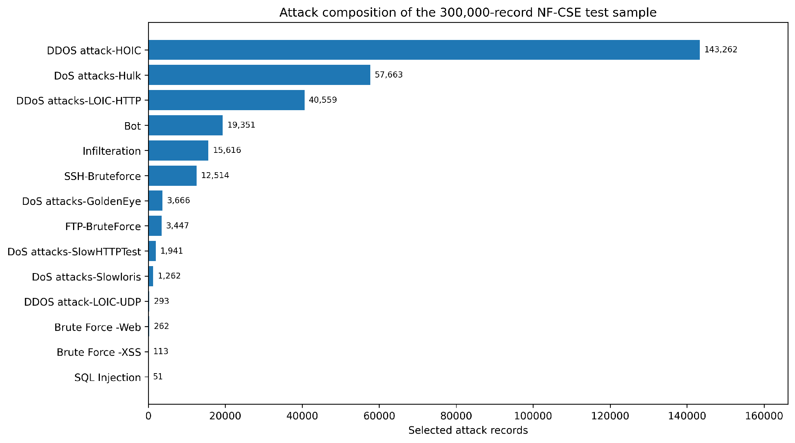
Figure 5. Attack composition in the selected 300,000-record labelled attack sample, reproduced from executed notebook counts.
Attack label | Selected records | Share of attack sample
DDOS attack-HOIC | 143,262 | 47.75%
DoS attacks-Hulk | 57,663 | 19.22%
DDoS attacks-LOIC-HTTP | 40,559 | 13.52%
Bot | 19,351 | 6.45%
Infilteration | 15,616 | 5.21%
SSH-Bruteforce | 12,514 | 4.17%
DoS attacks-GoldenEye | 3,666 | 1.22%
FTP-BruteForce | 3,447 | 1.15%
DoS attacks-SlowHTTPTest | 1,941 | 0.65%
DoS attacks-Slowloris | 1,262 | 0.42%
DDOS attack-LOIC-UDP | 293 | 0.10%
Brute Force -Web | 262 | 0.09%
Brute Force -XSS | 113 | 0.04%
SQL Injection | 51 | 0.02%

The selected attack population is dominated by DDOS attack-HOIC, DoS attacks-Hulk and DDoS attacks-LOIC-HTTP. Rare labels such as SQL Injection and Brute Force-XSS remain present but contribute very small counts. Aggregate recall therefore reflects the dominant attack families more strongly than the rare ones. Per-attack analysis is recommended in the later evaluation artefact so that a strong overall score does not hide failure on low-frequency scenarios.

10. Critical Evaluation of Portability and Domain Shift

10.1 Structural, transformation and semantic compatibility
Interpretation for the evaluation reports: the deliberately selected 400,000-normal/300,000-attack sample has an altered class prevalence and an approximate temporal-context reconstruction. Accordingly, its precision and F1 are sample-dependent, while a held-out normal-only false-positive rate remains interpretable for that tested normal population. Frozen-threshold failure is consistent with domain shift but cannot be attributed to one specific feature-mapping mechanism without an ablation or targeted comparison.
Compatibility layer | What was achieved | What remains uncertain
Structural | 21 expected portable inputs and exactly 41 ordered model columns. | None at the dimensional-contract level after assertions pass.
Transformation | The saved UNSW preprocessor is reused without refitting on NF-CSE. | Source scaling/encoding may place target values far outside source distributions.
Semantic | Direct byte/packet fields have close interpretations; mappings provide operational proxies. | Port-based services, flag-derived states and rolling ct_* context are not guaranteed to match UNSW semantics.
Statistical | All records can be scored by the frozen models. | Normal score distributions can still shift strongly between domains.

10.2 Downstream evidence of domain shift
The wider project subsequently applied the six frozen UNSW models and original UNSW thresholds to the NF-CSE test representation. False-positive rates were approximately 93.3% to 100% across the model set. This is not evidence that the 41-column file failed to execute; it is evidence that successful execution did not preserve the source normal-score distribution. The result motivated target-normal threshold recalibration and sensitivity testing in the evaluation artefact.
Several causes can coexist: exporter and aggregation differences, imperfect semantic mapping, source-derived scaling applied to shifted values, changed protocol/service composition, and the deliberately different class/traffic mix. The artefact therefore avoids claiming that target-normal recalibration “fixes” semantic domain shift. Recalibration only changes the decision operating point; it does not make the feature distributions identical.

10.3 Design decisions and justification
Decision | Reason | Trade-off
Use NF-CSE only as target-domain evaluation input | Tests transfer rather than giving the model access to the target environment during development. | Frozen models may perform worse than retrained models; this is intentional.
Sample 700,000 from 18.9M | Makes evaluation tractable in student Colab resources while retaining substantial normal/attack populations. | Results describe the selected sample, not every source record.
Reuse saved UNSW preprocessor | Prevents target statistics from silently changing the source model contract. | Target values can be far outside source scaling ranges.
Map to 21 portable features | Creates a common operational interface shared with Zeek work. | Some features are proxies rather than exact equivalents.
Retain metadata separately | Supports attack analysis and traceability without feeding identifiers to models. | Metadata itself can be sensitive and needs controlled access.
Preserve source row order after sampling | Allows rolling context to follow source chronology among retained rows. | Skipped source flows mean rolling counts are approximate.

11. Reproducibility and Quality Assurance

11.1 Controls already demonstrated
Control | Evidence
Randomness | NumPy and Python seeds set to 42; exact normal sample uses random_state=42; attack selection is stratified.
Source existence | CSV, UNSW preprocessor and source feature-order files checked before processing.
Traceability | Original _row_id retained in metadata and used to restore source order.
Input contract | 21 portable feature names checked against the saved preprocessor where supported.
Output contract | 41 columns, output-name verification/reordering, and exact saved order.
Numerical safety | Final matrix asserted finite; recorded NaN=0 and inf=0.
Evidence export | Machine-readable summary, feature order, metadata, preview, distributions and NPZ saved.

11.2 Reproducibility hardening required before final archive
- Add one visible configuration cell defining every variable used by the chunk/sampling stage before that stage executes.
- Run Runtime → Restart session / Run all in Colab and confirm the same final assertions from a clean state.
- Export a requirements.txt or environment snapshot with pandas, NumPy, scikit-learn, joblib and matplotlib versions.
- Commit the final notebook, feature_order_41.json, processing_summary.json and a small preview to the team repository; link the multi-gigabyte dataset rather than committing it.
- Add the public Colab share URL and project repository URL to this artefact and the Delivered Technical Artefacts table.

11.3 Recommended additional verification
- Perform a cross-chunk duplicate audit using stable row hashes if duplicate completeness matters to later claims.
- Compare robust quantiles and PSI for each of the 21 portable numeric features between UNSW normal and NF-CSE normal traffic before scoring.
- Validate the seven ct_* proxy formulas against the intended UNSW definitions on a small controlled sequence.
- Retain row-level anomaly scores in the evaluation stage so score-distribution shift can be visualised directly rather than inferred only from FPR.

12. Ethical and Professional Considerations
The raw dataset and saved metadata contain network identifiers such as source/destination IP addresses and ports. These values are needed temporarily for feature construction and investigation but are not included as direct model inputs. Repository outputs should follow data-minimisation principles: retain only the metadata necessary for verification, avoid publishing unnecessary endpoint identifiers, and comply with the UQ dataset conditions for academic use.
Professional reporting also requires separating an anomaly score from a confirmed intrusion. The NF-CSE sample has a deliberately altered class balance and contains mapped features whose semantics are not exact replicas of UNSW. Presenting a high or low model score without these caveats could overstate deployment readiness. The artefact therefore reports class counts, mapping limitations, false-positive behaviour and reproducibility constraints explicitly.

13. Limitations and Recommendations
Limitation | Why it matters | Recommended action
Within-chunk, not global, deduplication | Duplicates spanning chunk boundaries can remain. | Use stable hashes or a second-stage deduplication audit.
Sampling changes traffic sequence density | Rolling last-100 features operate on retained records, not every original flow. | Validate proxy counts on a contiguous unsampled subset or reconstruct before sampling.
Port-based service inference | Application traffic on non-standard ports may be misclassified. | Use richer application metadata where a deployment sensor provides it.
TCP-flag state mapping is heuristic | UNSW state semantics may not be reproduced exactly. | Document a state crosswalk and validate on known packet traces.
No public Colab/repository URL embedded | Marker cannot navigate from report to implementation link. | Add final share links before submission.
Notebook configuration state is incomplete in uploaded copy | Clean-runtime reproduction is not currently guaranteed from the file alone. | Add a configuration cell and rerun top-to-bottom.
Evaluation sample is rebalanced | Precision does not represent real production prevalence. | Report FPR, false alerts per 1,000 normals and prevalence caveat.
Dataset is a benchmark, not the SME network | Generalisation conclusions remain experimental. | Use the separate GNS3/Zeek practical dataset as an independent deployment-style check.

14. Conclusion
This artefact converts a large external NIDS benchmark into a controlled cross-domain input for the project without retraining the source models or refitting their preprocessing. The executed Colab workflow scanned 18,893,708 flows, selected 700,000 labelled evaluation records, engineered a 21-feature portable representation, reused the saved UNSW preprocessor and verified a finite 700,000 × 41 model-ready matrix. It also exported the metadata and configuration evidence needed to trace later model results back to the exact target data.
The deeper engineering contribution is the treatment of portability as more than column count. Direct mappings, derived formulas, categorical heuristics and rolling context proxies have different levels of semantic fidelity. By documenting those differences, the artefact provides a defensible explanation for why frozen thresholds can fail even when the target data can be scored successfully. This creates a clear hand-off to the cross-domain evaluation and threshold-recalibration artefact rather than claiming that preprocessing alone solves domain shift.

Appendix A - Exact 41-Column Model Contract
Column | Column | Column
1. dur | 2. spkts | 3. dpkts
4. sbytes | 5. dbytes | 6. rate
7. sload | 8. dload | 9. smean
10. dmean | 11. ct_srv_src | 12. ct_srv_dst
13. ct_dst_ltm | 14. ct_src_ltm | 15. ct_src_dport_ltm
16. ct_dst_sport_ltm | 17. ct_dst_src_ltm | 18. is_sm_ips_ports
19. proto_arp | 20. proto_other | 21. proto_tcp
22. proto_udp | 23. service_- | 24. service_dns
25. service_ftp | 26. service_ftp-data | 27. service_http
28. service_pop3 | 29. service_radius | 30. service_smtp
31. service_snmp | 32. service_ssh | 33. state_CON
34. state_ECO | 35. state_FIN | 36. state_INT
37. state_PAR | 38. state_REQ | 39. state_RST
40. state_URN | 41. state_no

This ordering is explicitly declared in the supplied notebook and is written to feature_order_41.json. The transform code attempts to verify and reorder generated names to this contract before saving the final NPZ.

Appendix B - Implementation Evidence Index
Evidence item | What it proves
Notebook setup and path checks | Colab/Drive environment, source CSV, saved UNSW artefacts and output locations.
Full-file scan output | 18,893,708 rows inspected; candidate pools created; sample counts recorded.
Portable feature output | 700,000 × 21; protocol, service and state distributions; missing values=0.
Preprocessor transform output | 21 expected inputs; 41 outputs; all 700,000 rows transformed.
Final verification output | 700,000 × 41, 400k normal, 300k attack, NaN=0, inf=0, assertions passed.
Attack distribution graph | Selected per-attack counts used in this report.
Saved JSON/CSV/NPZ paths | Machine-readable provenance and model-input artefacts.
Public share URLs | Not embedded in supplied notebook; must be inserted by the team before submission.

References
Chandola, V., Banerjee, A. & Kumar, V. (2009) 'Anomaly detection: A survey', ACM Computing Surveys, 41(3), pp. 1-58.
Pedregosa, F. et al. (2011) 'Scikit-learn: Machine learning in Python', Journal of Machine Learning Research, 12, pp. 2825-2830.
Ring, M., Wunderlich, S., Scheuring, D., Landes, D. & Hotho, A. (2019) 'A survey of network-based intrusion detection data sets', Computers & Security, 86, pp. 147-167.
Saito, T. & Rehmsmeier, M. (2015) 'The precision-recall plot is more informative than the ROC plot when evaluating binary classifiers on imbalanced datasets', PLOS ONE, 10(3), e0118432.
Sarhan, M., Layeghy, S., Moustafa, N. & Portmann, M. (2021) 'NetFlow Datasets for Machine Learning-Based Network Intrusion Detection Systems', Big Data Technologies and Applications, pp. 117-135. doi:10.1007/978-3-030-72802-1_9.
Sarhan, M., Layeghy, S. & Portmann, M. (2022) 'Towards a Standard Feature Set for Network Intrusion Detection System Datasets', Mobile Networks and Applications, 27. doi:10.1007/s11036-021-01843-0.
Sommer, R. & Paxson, V. (2010) 'Outside the closed world: On using machine learning for network intrusion detection', Proceedings of the IEEE Symposium on Security and Privacy, pp. 305-316.
University of Queensland (2023) NF-CSE-CIC-IDS2018-v2 [dataset], DOI: 10.48610/e9636b7, available at: https://researchdata.edu.au/nf-cse-cic-ids2018-v2/3370551 (accessed 8 October 2026).
University of Queensland Cyber Research Centre (n.d.) Machine Learning-Based NIDS Datasets, available at: https://www.cyber.uq.edu.au/node/824 (accessed 8 October 2026).

